**Q.) Draw a molecule using ADMETlab 2.0**

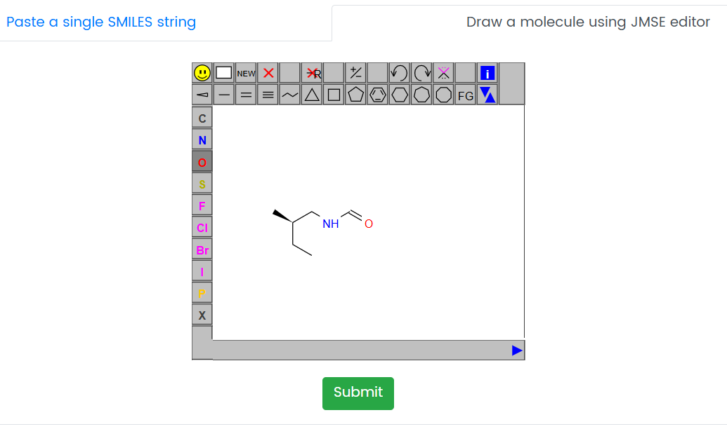

Smiles - **CC[C@@H](C)CNC=O**

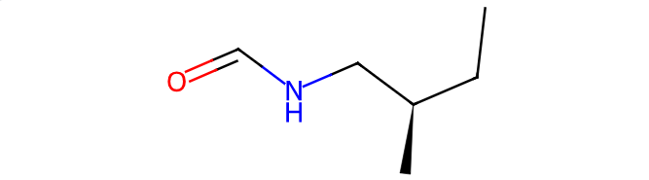

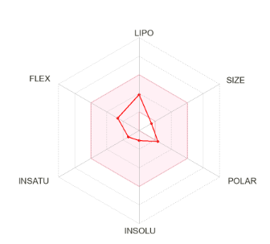

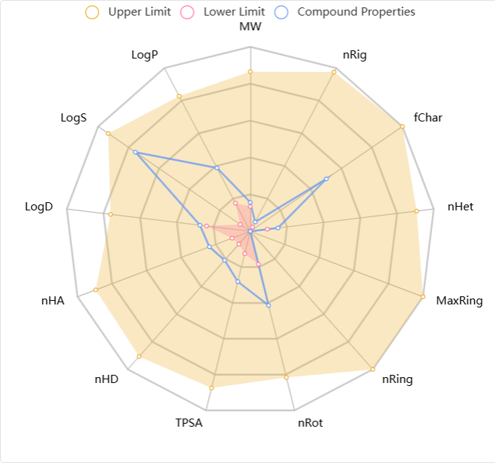

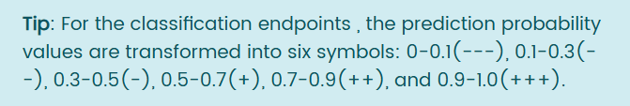

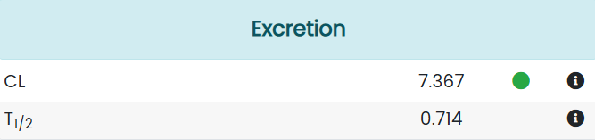

|  |  |  |
| --- | --- | --- |
| **Excretion** | **Values** | **Comments** |
| CL | 7.367 | Clearance, High: >15mLmin/Kg:moderate:5-15mL/min/Kg; low:<5ml/min/kg |
| T1/2 | 0.714 | Category 1: long half-life; category 0:short half-life; long half-life: >3h; short half-life: <3h, Output value- long life |

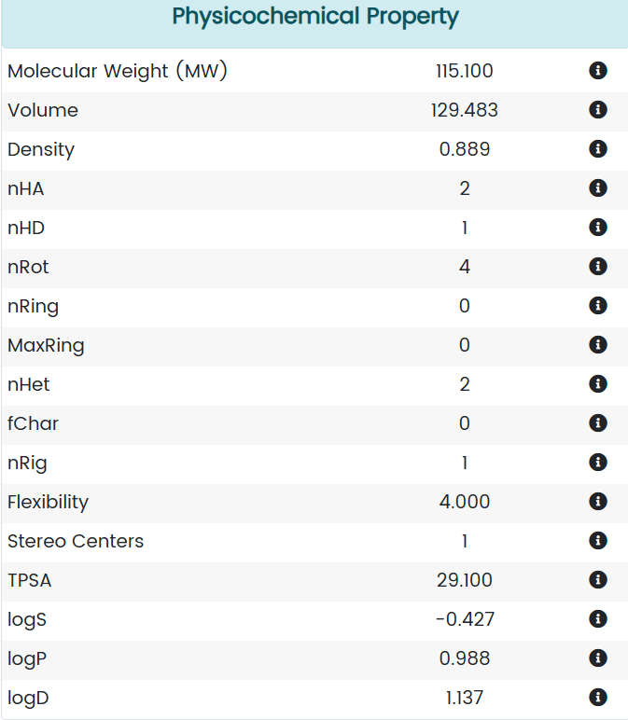

|  |  |  |
| --- | --- | --- |
| **Physiochemical property** | **Values** | **Comments** |
| Molecular Weight (MW) | 115.100 | Contains Hydrogen atoms.  Optimal : 100 - 600 |
| Volume | 129.483 | Van der Waals volume |
| Density | 0.889 | Density = MW/Volume |
| nHA | 2 | Number of hydrogen bond acceptors. Optimal:0-12 |
| nHD | 1 | Number of hydrogen bond donors  Optimal:0-7 |
| nRot | 4 | Number of rotatable bonds  Optimal: 0-7 |
| nRing | 0 | Number of rings  Optimal : 0-6 |
| MaxRing | 0 | Number of atoms in biggest rings  Optimal: 0-18 |
| nHet | 2 | Number of heteroatoms  Optimal: 1-15 |
| fChar | 0 | Formal charge  Optimal: 4-4 |
| nRig | 1 | Number of rigid bonds  Optimal:0-30 |
| Flexibility | 4.000 | Flexiblity = nRot/nRig |
| Stereo Centers | 1 | Optimal : greater than or equal to 2 |
| TPSA | 29.100 | Topological polar surface area  Optimal : 0-140 |
| logS | -0.427 | Log of the aqueous solublity.  Optimal: -4 to 0.5 log mol/L |
| logP | 0.988 | Log of the octanol/water partition  Optimal:0-3 |
| logD | 1.137 | logP at physiological pH 7.4  Optimal: 1-3 |

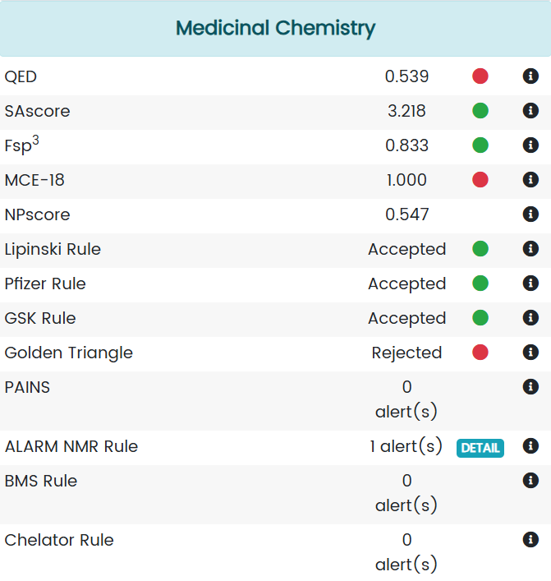

|  |
| --- |
| **Medicinal Chemistry** |
| **Properties** | **Values** | **Comments** |
| QED | 0.539 | A measure of drug-likeness based on the concept of desirability.  Attractive: >0.67; Unattractive: 0.49 – 0.67; too complex: <0.34 |
| SAscore | 3.218 | Synthetic accessibility score is designed to estimate ease of synthesis of drug-like molecules. SAscore > 6 difficult to synthesize; SAscore <6, easy to synthesize |
| Fsp3 | 0.833 | The number of sp3 hybridised carbons / Total carbon count, >0.42 is a suitable value |
| MCE-18 | 1.000 | MCE-18 stands for medicinal chemistry evolution. MCE-18>45 is considered a value. |
| NPscore | 0.547 | Natural product-likeness score. Ranges from -5 to 5. The highest score is that of a molecule is a NP. |
| Lipinski Rule | Accepted | MW < 500; logP <5; Hacc <10; Hdon <5, A poor absorption or permeability is possible. |
| Pfizer Rule | Accepted | Log p < 3; TPSA < 75, Compounds with a high logP (>3) and low TPSA (>75) is toxic. |
| GSK Rule | Accepted | MW < 400; logP < 4, they have a more favourable ADMET profile. |
| Golden Triangle | Rejected | 200 < MW < 50; -2 < logD < 5, they have a more favourable ADMET profile |
| PAINS | 0 alert(s) | Pan Assay interference compounds, frequent hitters, alpha-screen artifacts, reactive profile. |
| ALARM NMR Rule | 1 alert(s) | Thiol reactive compounds |
| BMS Rule | 0 alert(s) | Undesirable, reactive compounds |
| Chelator Rule | 0 alert(s) | Chelating compounds |

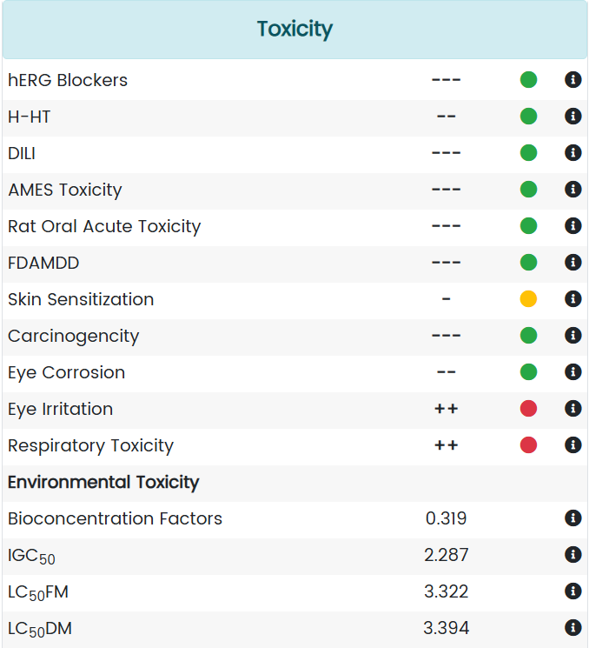

|  |  |  |
| --- | --- | --- |
| **Toxicity** | **Values** | **Comments** |
| hERG Blockers | --- | Category 1 : active; category 0: inactive; the output value is the probability of being active. |
| H-HT | -- | Human hepatoxicity, category1: H-HT positive(+); category 0: H-Ht negative(-); rhe output value is the probability of being toxic. |
| DILI | --- | Category 1: Ames positive(+); category 0: Ames negqtive(-); the output value is the probability of being toxic. |
| AMES Toxicity | --- | Category 0: low-toxicity ; category 1: high-toxicity; the output value is the probability of being highly toxic. |
| Rat Oral Acute Toxicity | --- | Category 0: low toxicity; category 1: high-toxicity; the output value is the probability of being highly toxic. |
| FDAMDD | --- | Maximum recommended Daily dose, category1: FDAMDD(+); Category 0: FDAMDD(-) |
| Skin Sensitization | - | Category 1 sensitizer; category 0: non-sensitizer; the output value is the probability of being sensitizer. |
| Carcinogencity | --- | Category 1: carcinogens category 0 non carcinogens; the output value is the probability of being toxic |
| Eye Corrosion | -- | Category 1 : corrosives; category 0 : non-corrosives; the output value is the probability of being corrosives |
| Eye Irritation | ++ | Category 1: irritants; category 0 : non-irritants, the output |
| Respiratory Toxicity | ++ | Category 1: respiratory toxicants; category 0; respiratory non-toxicants, the output value is the probability of being toxic. |
| Bioconcentration Factors | 0.319 | They are used for considering secondary poisoning potential and assessing risks to human health via the food chain. The unit is  -log10[(mg/L)/(1000*MW)] |
| IGC50 | 2.287 | Tetrahymena pyriformis 50% growth inhibition concentration. The unit is -log10[(mg/L)/(1000*MW)] |
| LC50FM | 3.322 | 96-hour fathead minnow 50% lethal concentration. The unit is -log10[(mg/L)/(1000*MW)] |
| LC50DM | 3.394 | 48- hour daphnia magna 50% lethal concentration. The unit is -log10[(mg/L)/(1000*MW)] |

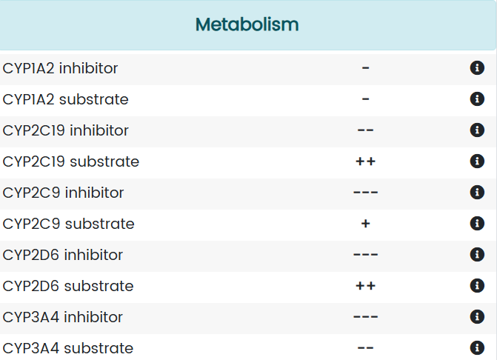

|  |
| --- |
| **Metabolism** |
| **Properties** | **Values** | **Comments** |
| CYP1A2 inhibitor | - | Category 1: inhibitory; category 0: Non- inhibitor; the output value is the  Probability of being inhibitor |
| CYP1A2 substrate | - | Category 1: Substrate; Category 0 : Non substrate; the output value is the  Probability of being substrate |
| CYP2C19 inhibitor | -- | Category 1: inhibitor; category 0 : non-inhibitor; the output value is the probability of being inhibitor |
| CYP2C19 substrate | ++ | Category 1: substrate; category 0 : non-substrate; the output value is the probability of being substrate |
| CYP2C9 inhibitor | --- | Category 1: inhibitor; category 0 : non-inhibitor; the output value is the probability of being inhibitor |
| CYP2C9 substrate | + | Category 1: substrate; category 0 : non-substrate; the output value is the probability of being substrate |
| CYP2D6 inhibitor | --- | Category 1: inhibitor; category 0 : non-inhibitor; the output value is the probability of being inhibitor |
| CYP2D6 substrate | ++ | Category 1: substrate; category 0 : non-substrate; the output value is the probability of being substrate |
| CYP3A4 inhibitor | --- | Category 1: inhibitor; category 0 : non-inhibitor; the output value is the probability of being inhibitor |
| CYP3A4 substrate | -- | Category 1: substrate; category 0 : non-substrate; the output value is the probability of being substrate |